Pr. 26.9.2026
Terry's Polio Eradication Update
For The Week Ending 9/26/26

Dear Polio Eradication Warriors,

Seven new Wild Polio paralysis cases were reported this week. We are now 4
weeks since the most recent report of a child being paralyzed by the Wild Polio Virus in Afghanistan.

We Can See The Finish Line to Global Polio Eradication!

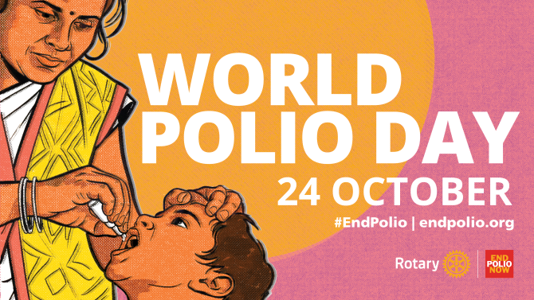


Let's Advocate, Donate & Educate to END POLIO NOW & FOREVER!


Total Wild Polio cases | Year-to-date 2026 | Total  2025 | Total  2024 | Total  2023 | Total  2022
Globally | 36 | 52 | 99 | 12 | 30
- in endemic countries: | 36 | 52 | 99 | 12 | 22

2026 YTD Total Polio Cases (36 Wild + 159 Variant) = 195
2025 Year Total Polio Cases (52 Wild + 233 Variant) = 285

2024 Total Polio Cases (99 Wild + 466 Variant) = 565
2023 Total Polio Cases (12 Wild + 524 Variant) = 536
2022 Total Polio Cases (30 Wild + 914 Variant) = 944

2026 Circulating Variant Polio Case Total - 159 Angola 1, Central African Republic 4, Chad 9, DRC 55, Ethiopia 9, LAO PDR 3, Madagascar 2, Malawi 2, Mali 3, Niger 1, Nigeria 47, Somalia 6, South Sudan 13, Sudan 4,Togo 2

2025 Circulating Variant Polio Case Total - 233 Algeria 1, Angola 19, Benin 3, Burkina Faso 1, Cameroon 1, Central African Republic 2, Chad 35, Djibouti 1, Democratic Republic of Congo 8, Ethiopia 41, Guinea 2, Lao PDR 1, Mali 1, Niger 3, Nigeria 72, Papua New Guinea - 5, Somalia 2, Sudan 7, Yemen 30
2024 Circulating Variant Polio Case Total - 466 Algeria - 1, Angola - 9, Benin - 2, Cameroon - 3, Chad - 39, Cote d'Ivoire - 1, DR Congo - 25, Ethiopia - 44, Guinea - 9, Indonesia - 8, Liberia - 1,Mali - 1, Mozambique - 1, Niger - 17, Nigeria - 101, Occupied Palestinian Territory - 1, Senegal - 1, Somalia - 7, South Sudan - 11, Yemen - 167

2026 Wild Polio Case Total - 36 Pakistan 4, Afghanistan 32
2025 Wild Polio Case Total 52 - Afghanistan 21 - Pakistan 31

2024 Wild Polio Cases Total 99 - Afghanistan 25 - Pakistan 74
2023 Wild Polio Cases Total 12 - Afghanistan 6, Pakistan 6
2023 Circulating Variant Polio Cases 524 in 23 Countries

New Polio Cases & Samples reported this week
• Afghanistan: seven WPV1 cases
• Pakistan: one WPV1-positive environmental sample
• Chad: one cVDPV2 case
• DR Congo: three cVDPV2 cases

Quote of the Day - "Life is like an ever-shifting kaleidoscope - a slight change, and all patterns alter." - Sharon Salzberg (1952 - ) Meditation Pioneer & Author

The Final Two Polio Endemic Countries

Pakistan No new Wild Polio cases reported this week. Four Wild Polio cases reported in 2026. Thirty-one Wild Polio cases reported in 2025. Seventy-four Wild Polio cases reported in 2024.Six Wild Polio Cases reported in 2023. The most recent case had an onset of paralysis on 8/7/26. One new WPV1 Environmental Sample and no cVDPV2 Positive Environmental Samples were reported this week in Pakistan.

Afghanistan Seven new Wild Polio cases reported this week. Thirty-two Wild Polio cases reported in 2026. Twenty One Wild Polio cases reported in 2025. Twenty-five Wild Polio cases reported in 2024. Six Wild Polio Cases reported in 2023. The most recent case had an onset of paralysis on 8/31/26. No new WPV1 Environmental Samples and no cVDPV2 Positive Environmental Samples were reported this week in Afghanistan.

Advocate, Donate & Educate to END POLIO NOW & FOREVER!

Over 3 billion Children Immunized
Over $3 billion raised by Rotary for Polio Eradication
21,000,000 Children Saved from the Paralysis of Polio
1.6 million lives Saved thanks to the Polio Vaccines
Together, We End Polio!

Terry Ziegler, Polio Update Newsletter Editor

Rotary Region 36 END POLIO NOW Coordinator 2024-27

