Terry's Polio Eradication Update
For The Week Ending 10/17/26

Dear Polio Eradication Warriors,

Two new Wild Polio paralysis cases were reported this week. We are now 4
weeks since the most recent report of a child being paralyzed by the Wild Polio Virus in Pakistan.
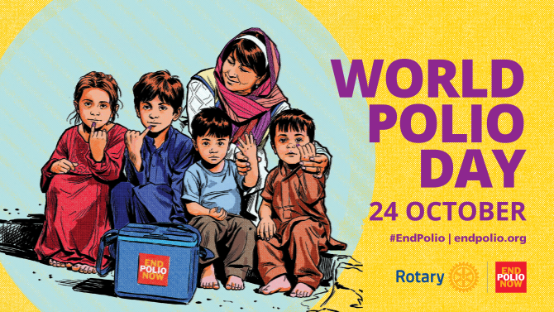

We Can See The Finish Line to Global Polio Eradication!
Please donate to Rotary's Polio Fund this month. Your donation will be matched $2 to your $1 by The Gates Foundation.

Let's Advocate, Donate & Educate to END POLIO NOW & FOREVER!


Total Wild Polio cases | Year-to-date 2026 | Total  2025 | Total  2024 | Total  2023 | Total  2022
Globally | 42 | 52 | 99 | 12 | 30
- in endemic countries: | 42 | 52 | 99 | 12 | 22

2026 YTD Total Polio Cases (42 Wild + 187 Variant) = 229
2025 Year Total Polio Cases (52 Wild + 233 Variant) = 285

2024 Total Polio Cases (99 Wild + 466 Variant) = 565
2023 Total Polio Cases (12 Wild + 524 Variant) = 536
2022 Total Polio Cases (30 Wild + 914 Variant) = 944
2026 Circulating Variant Polio Case Total - 187 Angola 1, Central African Republic 5, Chad 9, DRC 71, Ethiopia 9, LAO PDR 3, Madagascar 4, Malawi 2, Mali 3, Niger 1, Nigeria 49, Somalia 6, South Sudan 20, Sudan 4,Togo 2

2025 Circulating Variant Polio Case Total - 233 Algeria 1, Angola 19, Benin 3, Burkina Faso 1, Cameroon 1, Central African Republic 2, Chad 35, Djibouti 1, Democratic Republic of Congo 8, Ethiopia 41, Guinea 2, Lao PDR 1, Mali 1, Niger 3, Nigeria 72, Papua New Guinea - 5, Somalia 2, Sudan 7, Yemen 30
2024 Circulating Variant Polio Case Total - 466 Algeria - 1, Angola - 9, Benin - 2, Cameroon - 3, Chad - 39, Cote d'Ivoire - 1, DR Congo - 25, Ethiopia - 44, Guinea - 9, Indonesia - 8, Liberia - 1,Mali - 1, Mozambique - 1, Niger - 17, Nigeria - 101, Occupied Palestinian Territory - 1, Senegal - 1, Somalia - 7, South Sudan - 11, Yemen - 167

2026 Wild Polio Case Total - 42 Pakistan 6, Afghanistan 36
2025 Wild Polio Case Total 52 - Afghanistan 21 - Pakistan 31

2024 Wild Polio Cases Total 99 - Afghanistan 25 - Pakistan 74
2023 Wild Polio Cases Total 12 - Afghanistan 6, Pakistan 6
2023 Circulating Variant Polio Cases 524 in 23 Countries

New Polio Cases & Samples reported this week
• Afghanistan : one WPV1 case and one WPV1-positive environmental sample
• Pakistan : one WPV1 case
• DR Congo : seven cVDPV2 cases and one cVDPV2-positive environmental sample
• Madagascar : two cVDPV1 cases
• Mali : two cVDPV2 cases
• Nigeria : one cVDPV3 case
• Somalia : four cVDPV2-positive environmental samples
• South Sudan : one cVDPV1 case

Quote of the Day - "We sleep, but the loom of life never stops, and the pattern which was weaving when the sun went down is weaving when it comes up in the morning." - Henry Ward Beecher (1813 - 1887) Clergyman and Abolitionist

The Final Two Polio Endemic Countries

Pakistan One new Wild Polio case reported this week. Six Wild Polio cases reported in 2026. Thirty-one Wild Polio cases reported in 2025. Seventy-four Wild Polio cases reported in 2024. The most recent case had an onset of paralysis on 9/13/26. No new WPV1 Environmental Samples and no cVDPV2 Positive Environmental Samples were reported this week in Pakistan.

Afghanistan One new Wild Polio case reported this week. Thirty-six Wild Polio cases reported in 2026. Twenty One Wild Polio cases reported in 2025. Twenty-five Wild Polio cases reported in 2024. Six Wild Polio Cases reported in 2023. The most recent case had an onset of paralysis on 9/5/26. One new WPV1 Environmental Sample and no cVDPV2 Positive Environmental Samples were reported this week in Afghanistan.

Advocate, Donate & Educate to END POLIO NOW & FOREVER!

Over 3 billion Children Immunized
Over $3 billion raised by Rotary for Polio Eradication
21,000,000 Children Saved from the Paralysis of Polio
1.6 million Lives saved thanks to the Polio Vaccines
Together, We End Polio!

Terry Ziegler, Polio Update Newsletter Editor

Rotary Region 36 END POLIO NOW Coordinator 2024-27

